Elliptical-Region Generator

Definition
# Source: AI Source: Provided by: [Data Path: Persons Table -> ID Column: 1, Name_En Column: Motasem Essam] -> From: [ChatGPT] on [7/25/2026]
An Elliptical-Region Generator is a plane-region generator that uses a filled elliptical region (ellipse-shaped disk) to produce three-dimensional solids through rotation, translation, or other spatial movements.
Its most important applications include:
- Rotating an elliptical region around its major axis to generate a Prolate Spheroid.
- Rotating an elliptical region around its minor axis to generate an Oblate Spheroid.
- Translating an elliptical region to generate an Elliptic Cylinder.
When the ellipse is a circle (both semi-axes are equal), rotation around a principal axis generates a sphere.
Important distinction:
- An elliptical region is the filled area enclosed by an ellipse.
- An elliptical boundary is only the curved outline.
- Rotating the filled region generates a solid; rotating only its boundary generates a surface.

Geometric Representation
# Source: AI Source: Provided by: [Data Path: Persons Table -> ID Column: 1, Name_En Column: Motasem Essam] -> From: [ChatGPT] on [7/25/2026]
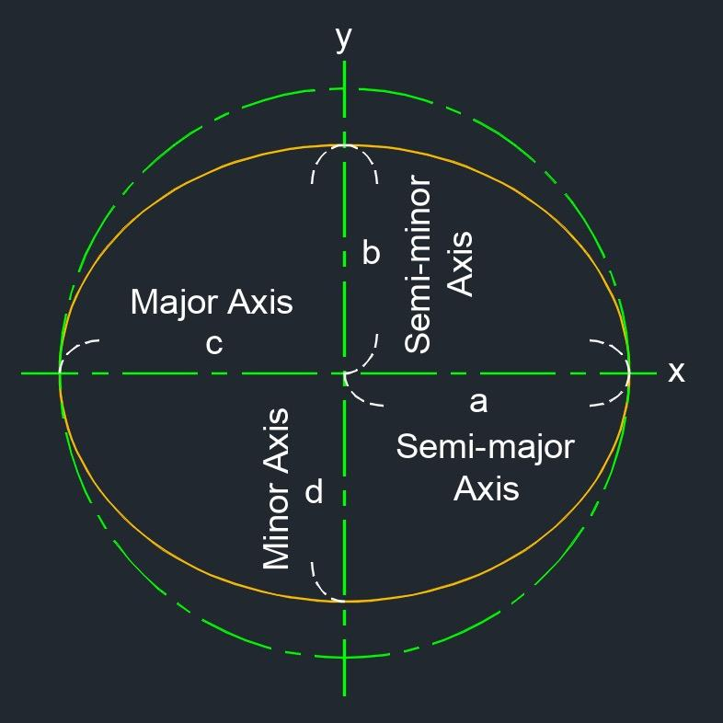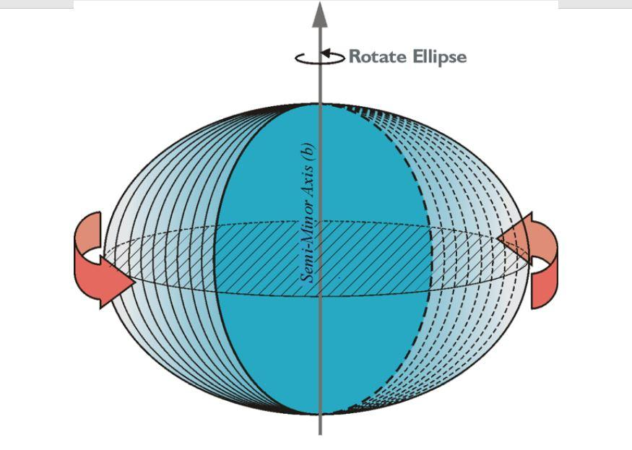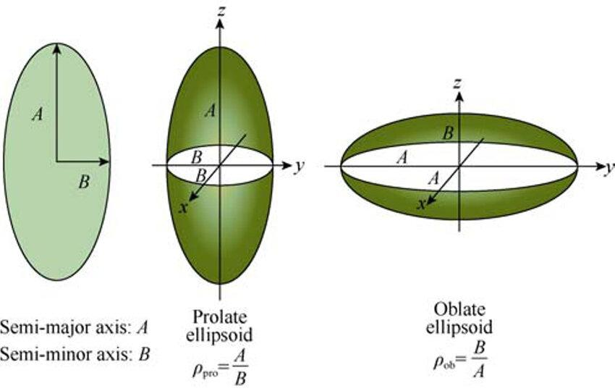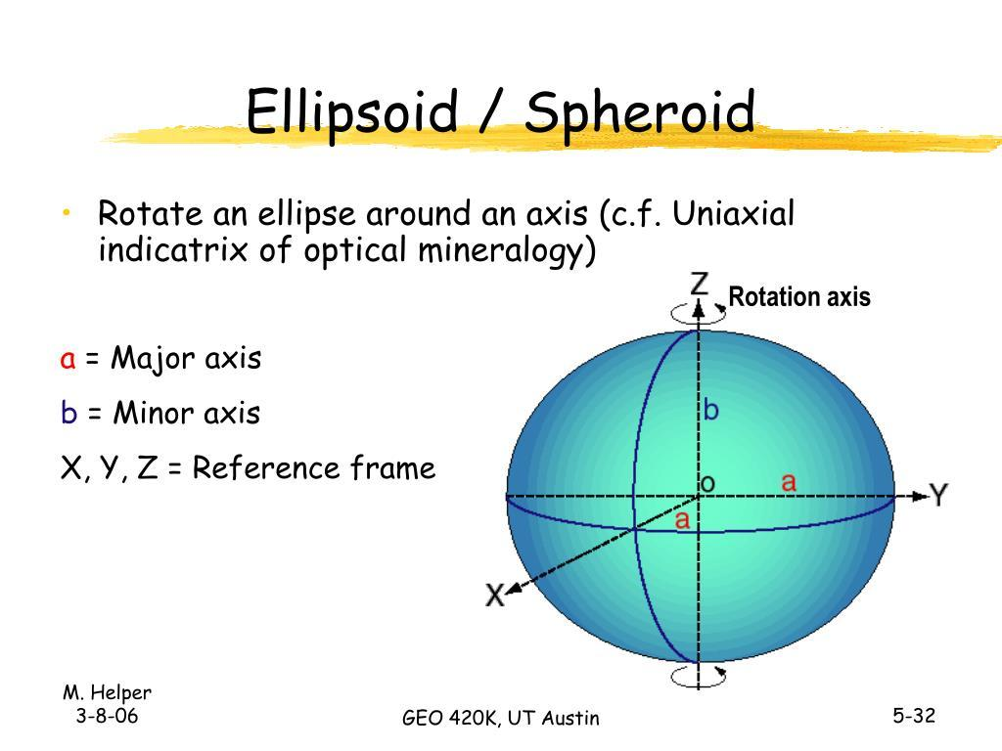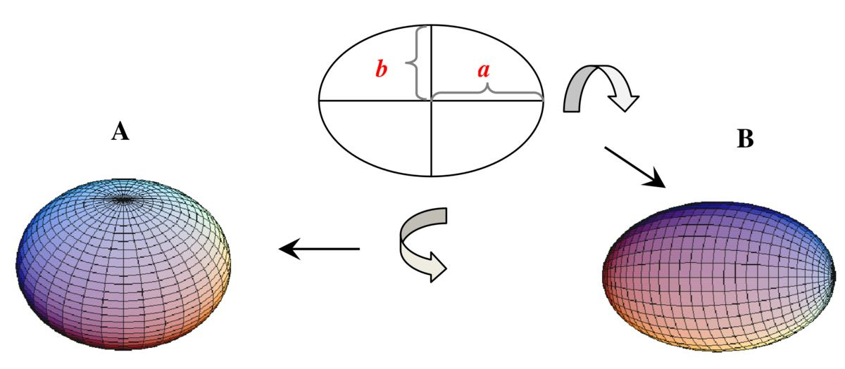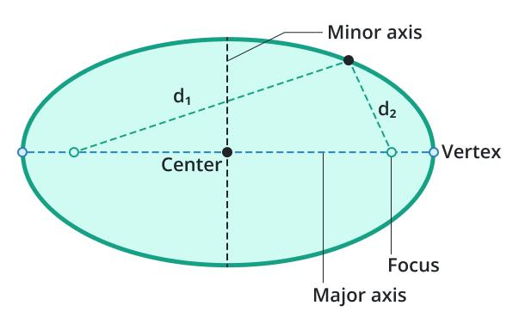

Geometric Structure
# Source: AI Source: Provided by: [Data Path: Persons Table -> ID Column: 1, Name_En Column: Motasem Essam] -> From: [ChatGPT] on [7/25/2026]
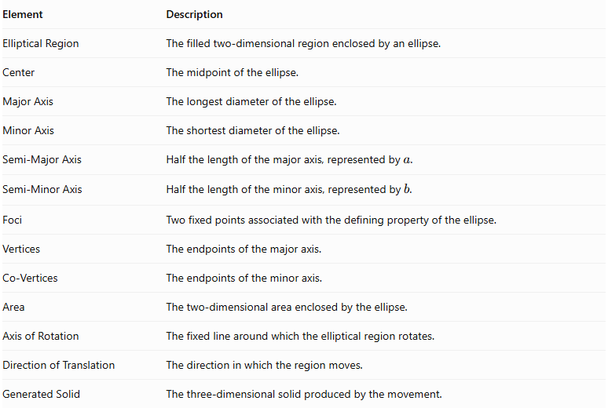
Element | Description
Elliptical Region | The filled two-dimensional region enclosed by an ellipse.
Center | The midpoint of the ellipse.
Major Axis | The longest diameter of the ellipse.
Minor Axis | The shortest diameter of the ellipse.
Semi-Major Axis | Half the length of the major axis, represented by $a$.
Semi-Minor Axis | Half the length of the minor axis, represented by $b$.
Foci | Two fixed points associated with the defining property of the ellipse.
Vertices | The endpoints of the major axis.
Co-Vertices | The endpoints of the minor axis.
Area | The two-dimensional area enclosed by the ellipse.
Axis of Rotation | The fixed line around which the elliptical region rotates.
Direction of Translation | The direction in which the region moves.
Generated Solid | The three-dimensional solid produced by the movement.

Types of Elliptical-Region Generators According to Movement

Rotational Elliptical-Region Generator
# Source: AI Source: Provided by: [Data Path: Persons Table -> ID Column: 1, Name_En Column: Motasem Essam] -> From: [ChatGPT] on [7/25/2026]
An elliptical region rotates around a fixed axis to generate a solid of revolution.
A. Rotation Around the Major Axis
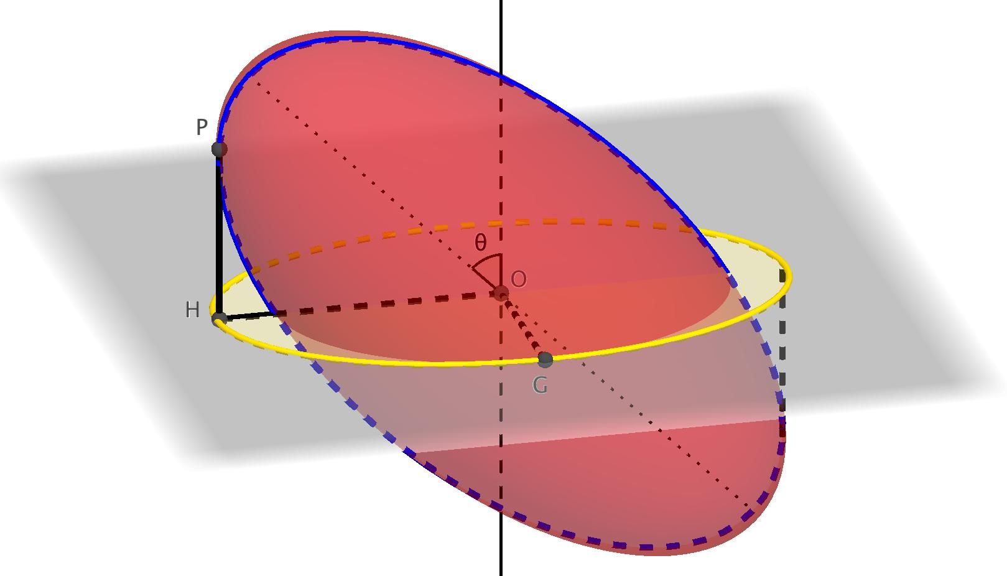
Generates a Prolate Spheroid (elongated spheroid).
Characteristics:
- The generated solid is elongated along the axis of rotation.
- Its cross-sections perpendicular to the rotation axis are circular.
- Its longest dimension is along the major axis.
- Its two equal shorter axes correspond to the original ellipse's semi-minor dimension.
B. Rotation Around the Minor Axis
Generates an Oblate Spheroid (flattened spheroid).
Characteristics:
- The generated solid is flattened along the axis of rotation.
- Its cross-sections perpendicular to the rotation axis are circular.
- Its two equal longer axes correspond to the original ellipse's semi-major dimension.
- Its shortest dimension is along the minor axis.
C. Rotation When Both Semi-Axes Are Equal
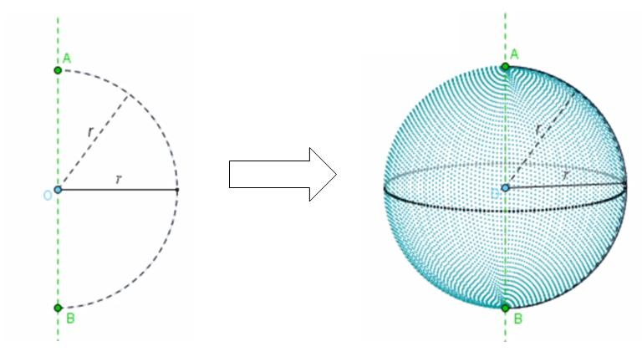
When:
$$a=b=r$$
The elliptical region becomes a circular region.
Rotating it around either principal axis generates a Solid Sphere.

Translational Elliptical-Region Generator
# Source: AI Source: Provided by: [Data Path: Persons Table -> ID Column: 1, Name_En Column: Motasem Essam] -> From: [ChatGPT] on [7/25/2026]
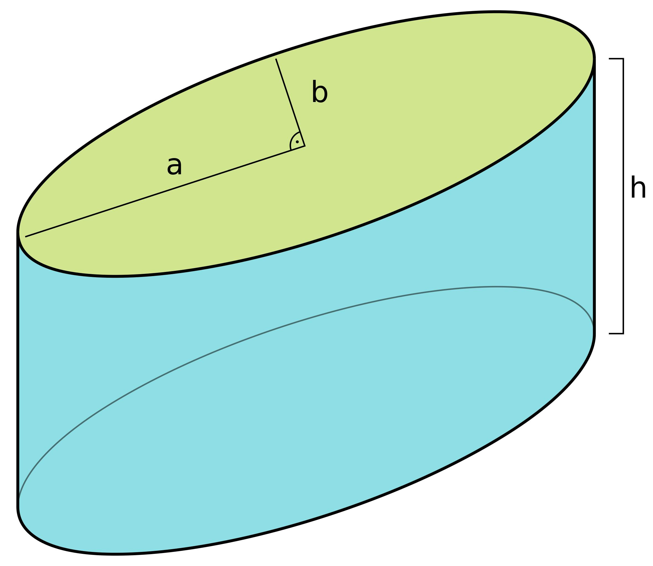
An elliptical region moves along a straight direction without changing its shape or orientation.
A. Perpendicular Translation
- Generates a Right Elliptic Cylinder.
- The original ellipse forms one base.
- The translated ellipse forms the opposite base.
- The translation distance determines the cylinder's height.
B. Oblique Translation
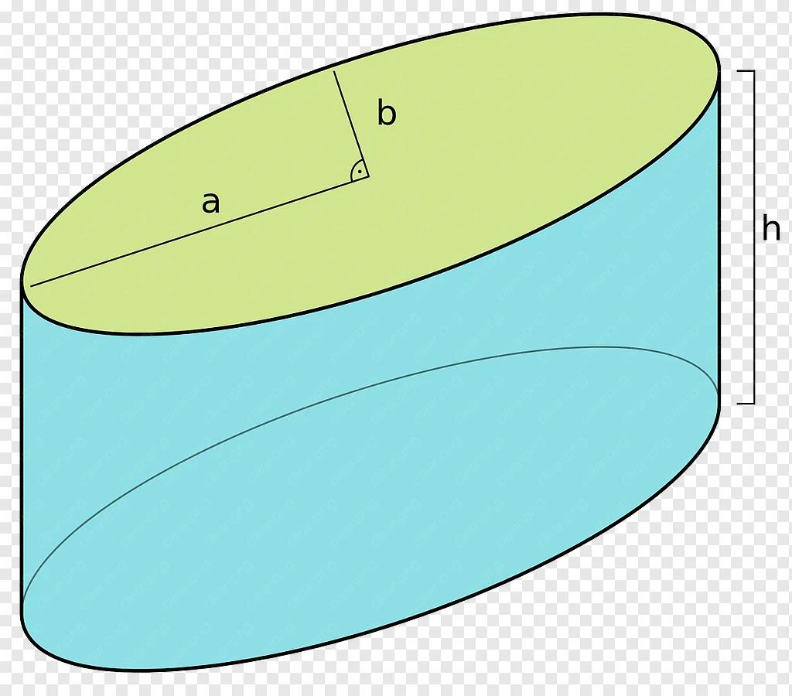
- Generates an Oblique Elliptic Cylinder.
- The two elliptical bases remain parallel and congruent.
- The translation direction is inclined relative to the plane of the elliptical region.
- The perpendicular distance between the bases determines the cylinder's height.

Combined Rotational and Translational Elliptical-Region Generator
# Source: AI Source: Provided by: [Data Path: Persons Table -> ID Column: 1, Name_En Column: Motasem Essam] -> From: [ChatGPT] on [7/25/2026]
An elliptical region can undergo rotation and translation simultaneously.
The resulting solid depends on the path and orientation of the region during its movement. Such motion can produce complex swept solids rather than a standard spheroid or elliptic cylinder.

Mathematical Representation
# Source: AI Source: Provided by: [Data Path: Persons Table -> ID Column: 1, Name_En Column: Motasem Essam] -> From: [ChatGPT] on [7/25/2026]
Let an elliptical region have:
- Semi-major axis: $a$
- Semi-minor axis: $b$
- Major axis length: $2a$
- Minor axis length: $2b$
For a non-circular ellipse:
$$a>b>0$$

Fundamental Measurements
# Source: AI Source: Provided by: [Data Path: Persons Table -> ID Column: 1, Name_En Column: Motasem Essam] -> From: [ChatGPT] on [7/25/2026]
Area of the elliptical region:
$$A=πab$$
Major axis:
$$D_{\text{major}}=2a$$
Minor axis:
$$D_{\text{minor}}=2b$$
Focal distance:
$$c=\sqrt{a^{2}-b^{2}}$$
Eccentricity:
$$e=\frac{c}{a}$$
Standard equation of a horizontal ellipse:
$$\frac{x^{2}}{a^{2}}+\frac{y^{2}}{b^{2}}=1$$

Rotation Around the Major Axis — Prolate Spheroid
# Source: AI Source: Provided by: [Data Path: Persons Table -> ID Column: 1, Name_En Column: Motasem Essam] -> From: [ChatGPT] on [7/25/2026]
When the elliptical region rotates around its major axis, it generates a Prolate Spheroid.
The resulting three-dimensional equation is:
$$\frac{x^{2}}{a^{2}}+\frac{y^{2}+z^{2}}{b^{2}}=1$$
The three principal semi-axes are:
$$a, b, b$$
Volume:
$$V=\frac{4}{3}π{ab}^{2}$$
Surface area:
$$S=2πb^{2}\left(1+\frac{a}{be}\sin^{-1}e\right)$$
Where:
$$e=\sqrt{1-\frac{b^{2}}{a^{2}}}$$

Rotation Around the Minor Axis — Oblate Spheroid
# Source: AI Source: Provided by: [Data Path: Persons Table -> ID Column: 1, Name_En Column: Motasem Essam] -> From: [ChatGPT] on [7/25/2026]
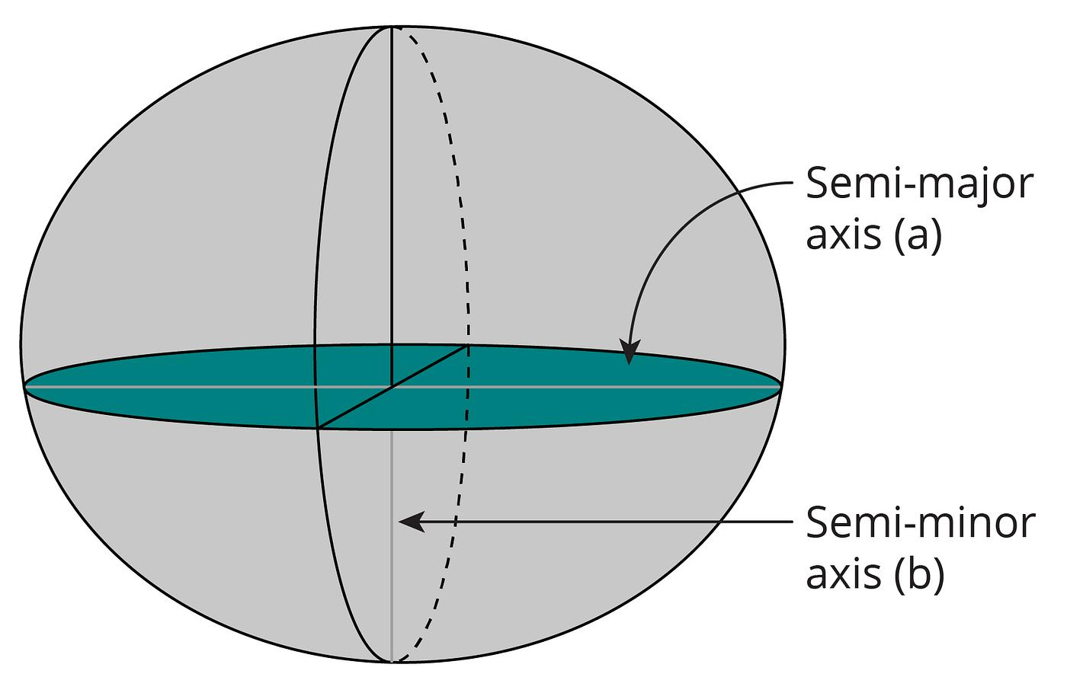
When the elliptical region rotates around its minor axis, it generates an Oblate Spheroid.
The resulting three-dimensional equation is:
$$\frac{x^{2}+y^{2}}{a^{2}}+\frac{z^{2}}{b^{2}}=1$$
The three principal semi-axes are:
$$a, a, b$$
Volume:
$$V=\frac{4}{3}πa^{2}b$$
Surface area:
$$S=2πa^{2}\left(1+\frac{1-e^{2}}{e}\tanh^{-1}e\right)$$
Where:
$$e=\sqrt{1-\frac{b^{2}}{a^{2}}}$$

Perpendicular Translation — Right Elliptic Cylinder
# Source: AI Source: Provided by: [Data Path: Persons Table -> ID Column: 1, Name_En Column: Motasem Essam] -> From: [ChatGPT] on [7/25/2026]
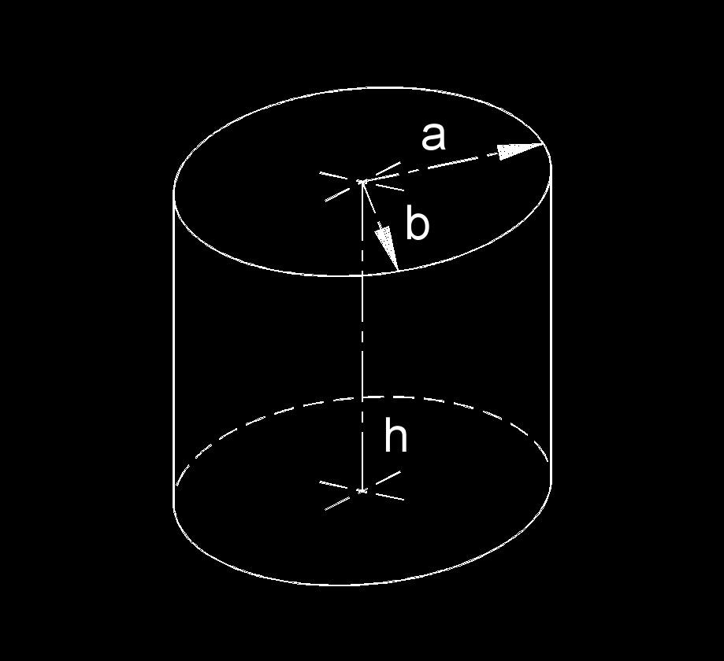
When an elliptical region is translated perpendicularly to its plane through a distance $h$, it generates a Right Elliptic Cylinder.
Volume:
$$V=πabh$$
Base area:
$$A_{b}=πab$$
The total surface area is:
$$S=2πab+Ph$$
Where $P$ is the circumference (perimeter) of the elliptical base.
The circumference of an ellipse generally has no elementary closed-form expression. It can be calculated using elliptic integrals or approximations.

Oblique Translation — Oblique Elliptic Cylinder
# Source: AI Source: Provided by: [Data Path: Persons Table -> ID Column: 1, Name_En Column: Motasem Essam] -> From: [ChatGPT] on [7/25/2026]
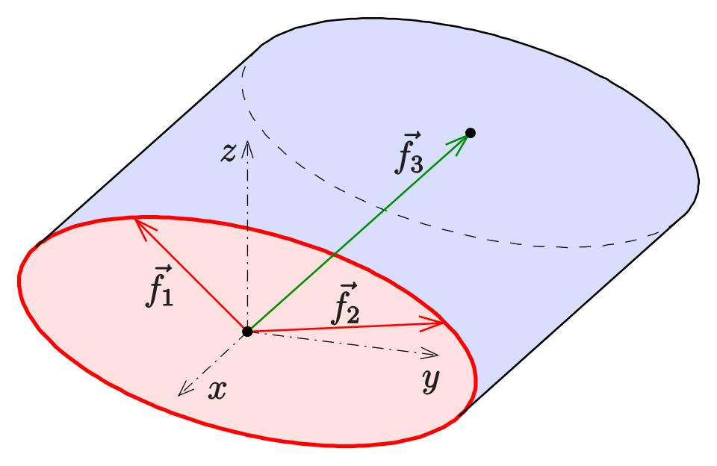
When an elliptical region is translated obliquely to its plane, it generates an Oblique Elliptic Cylinder.
Its volume is:
$$V=πabh$$
Where $h$ is the perpendicular distance between the two parallel elliptical bases.
The slanted translation distance is not necessarily equal to the cylinder's height.

Mathematical Properties
# Source: AI Source: Provided by: [Data Path: Persons Table -> ID Column: 1, Name_En Column: Motasem Essam] -> From: [ChatGPT] on [7/25/2026]
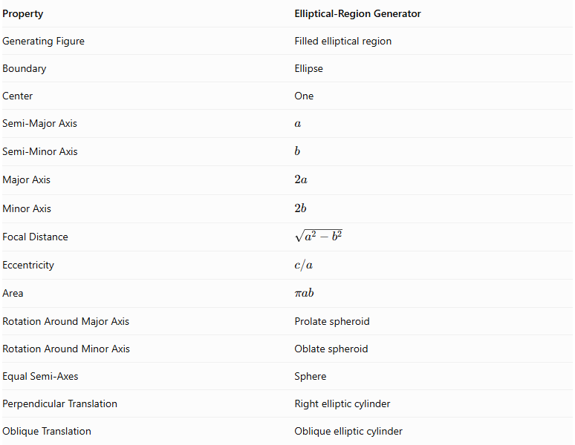
Property | Elliptical-Region Generator
Generating Figure | Filled elliptical region
Boundary | Ellipse
Center | One
Semi-Major Axis | $$a$$
Semi-Minor Axis | $$b$$
Major Axis | $$2a$$
Minor Axis | $$2b$$
Focal Distance | $$\sqrt{a^{2}-b^{2}}$$
Eccentricity | $$c/a$$
Area | $$πab$$
Rotation Around Major Axis | Prolate spheroid
Rotation Around Minor Axis | Oblate spheroid
Equal Semi-Axes | Sphere
Perpendicular Translation | Right elliptic cylinder
Oblique Translation | Oblique elliptic cylinder

Generated Surfaces and Solids

Prolate Spheroid
# Source: AI Source: Provided by: [Data Path: Persons Table -> ID Column: 1, Name_En Column: Motasem Essam] -> From: [ChatGPT] on [7/25/2026]
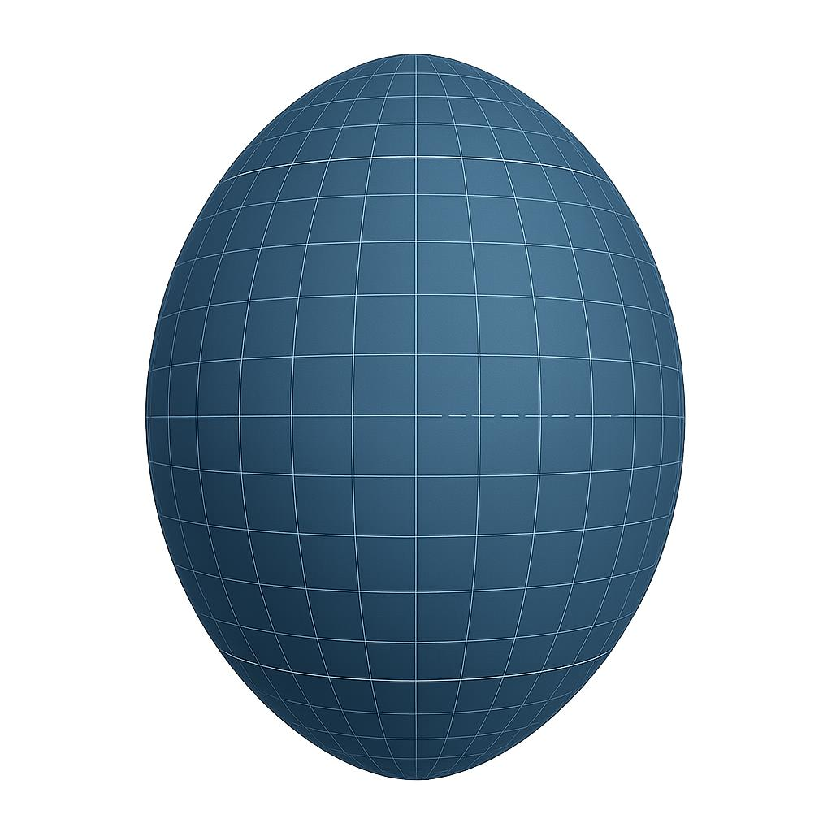
Generated by rotating an elliptical region around its major axis.

Oblate Spheroid
# Source: AI Source: Provided by: [Data Path: Persons Table -> ID Column: 1, Name_En Column: Motasem Essam] -> From: [ChatGPT] on [7/25/2026]
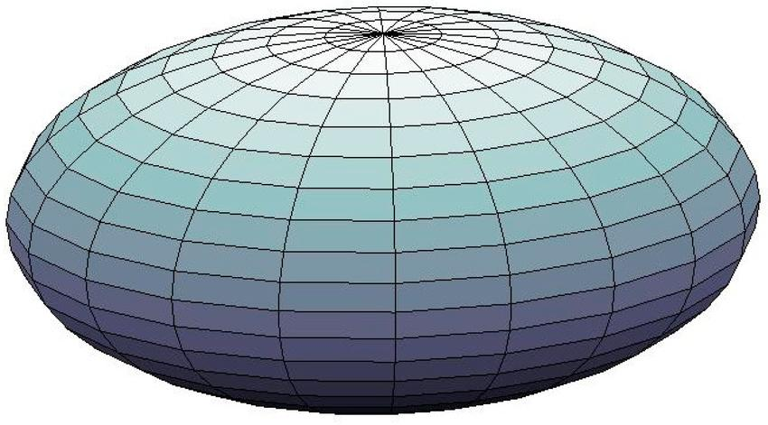
Generated by rotating an elliptical region around its minor axis.

Sphere
# Source: AI Source: Provided by: [Data Path: Persons Table -> ID Column: 1, Name_En Column: Motasem Essam] -> From: [ChatGPT] on [7/25/2026]
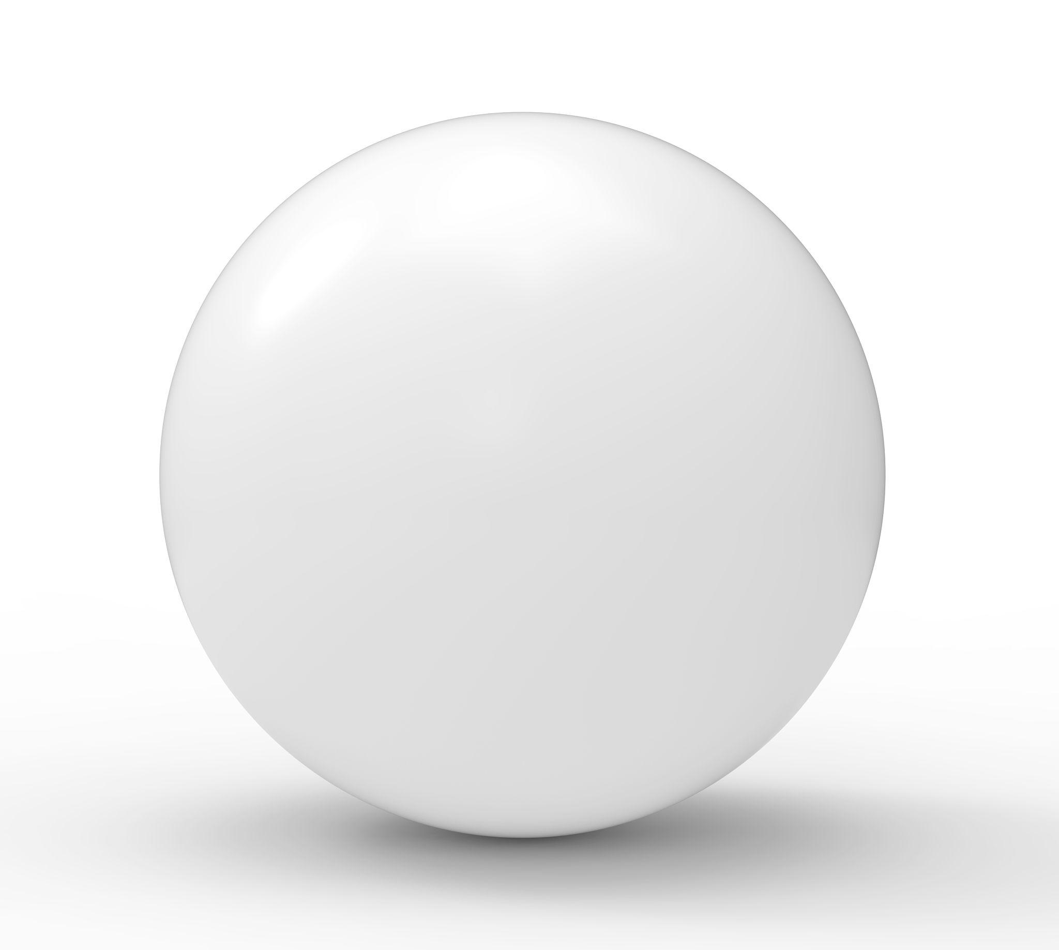
Generated when the elliptical region has equal semi-axes and rotates around a principal axis.

Right Elliptic Cylinder
# Source: AI Source: Provided by: [Data Path: Persons Table -> ID Column: 1, Name_En Column: Motasem Essam] -> From: [ChatGPT] on [7/25/2026]
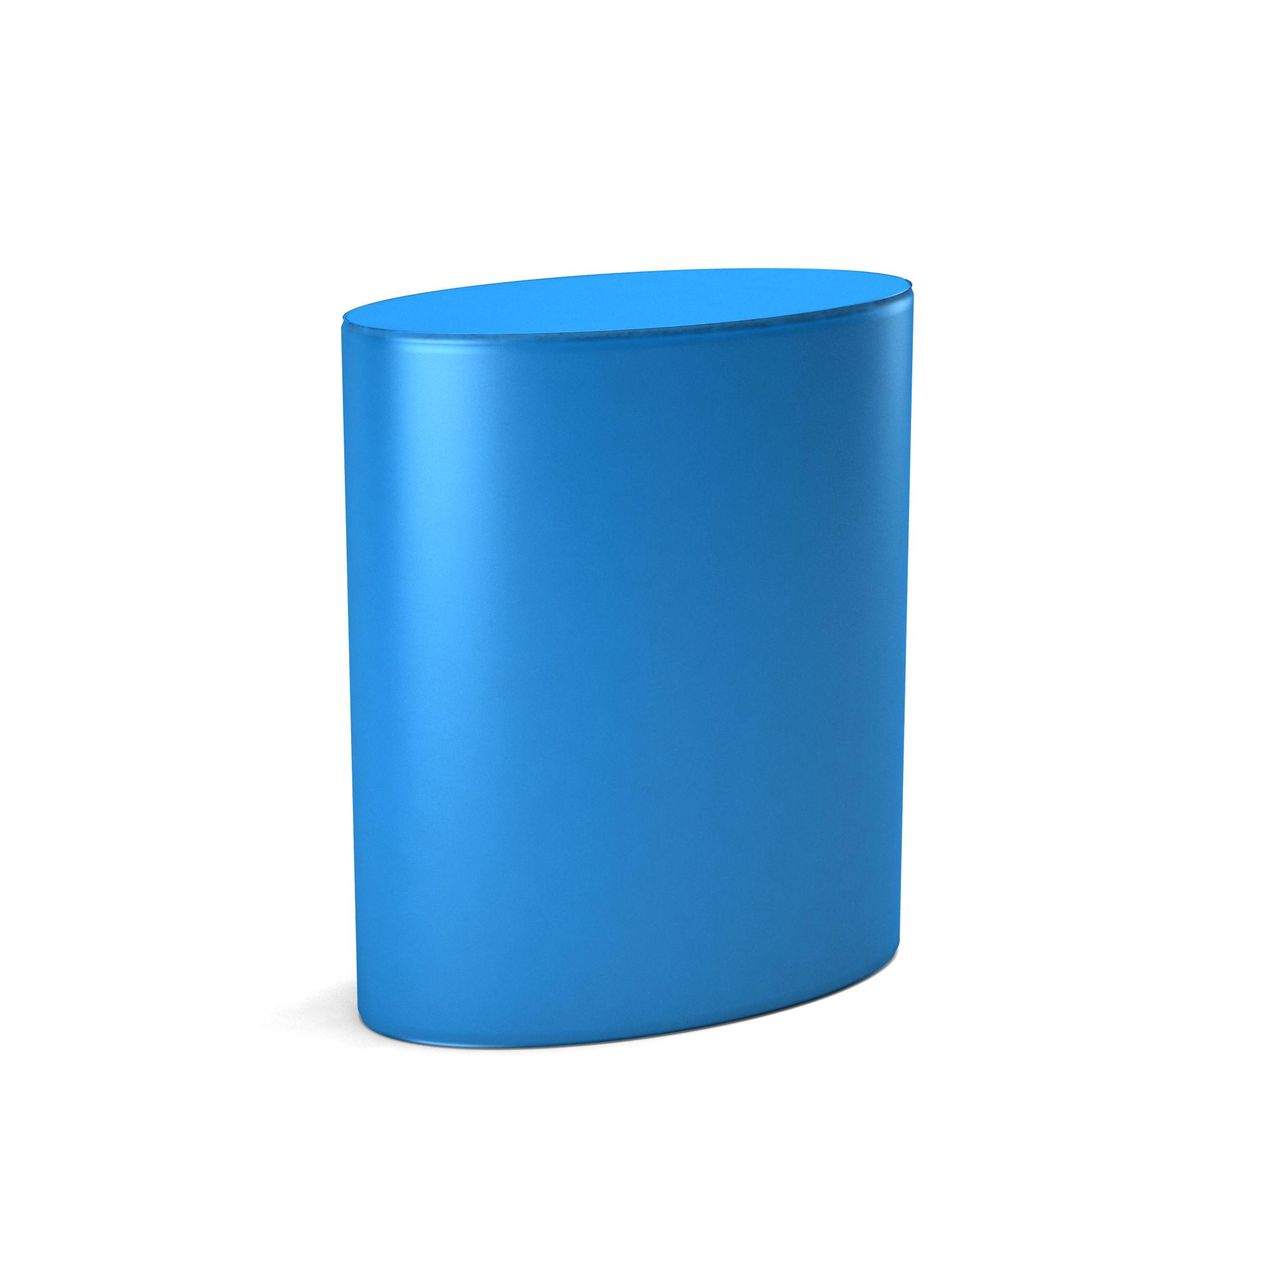
Generated by translating an elliptical region perpendicularly to its plane.

Oblique Elliptic Cylinder
# Source: AI Source: Provided by: [Data Path: Persons Table -> ID Column: 1, Name_En Column: Motasem Essam] -> From: [ChatGPT] on [7/25/2026]
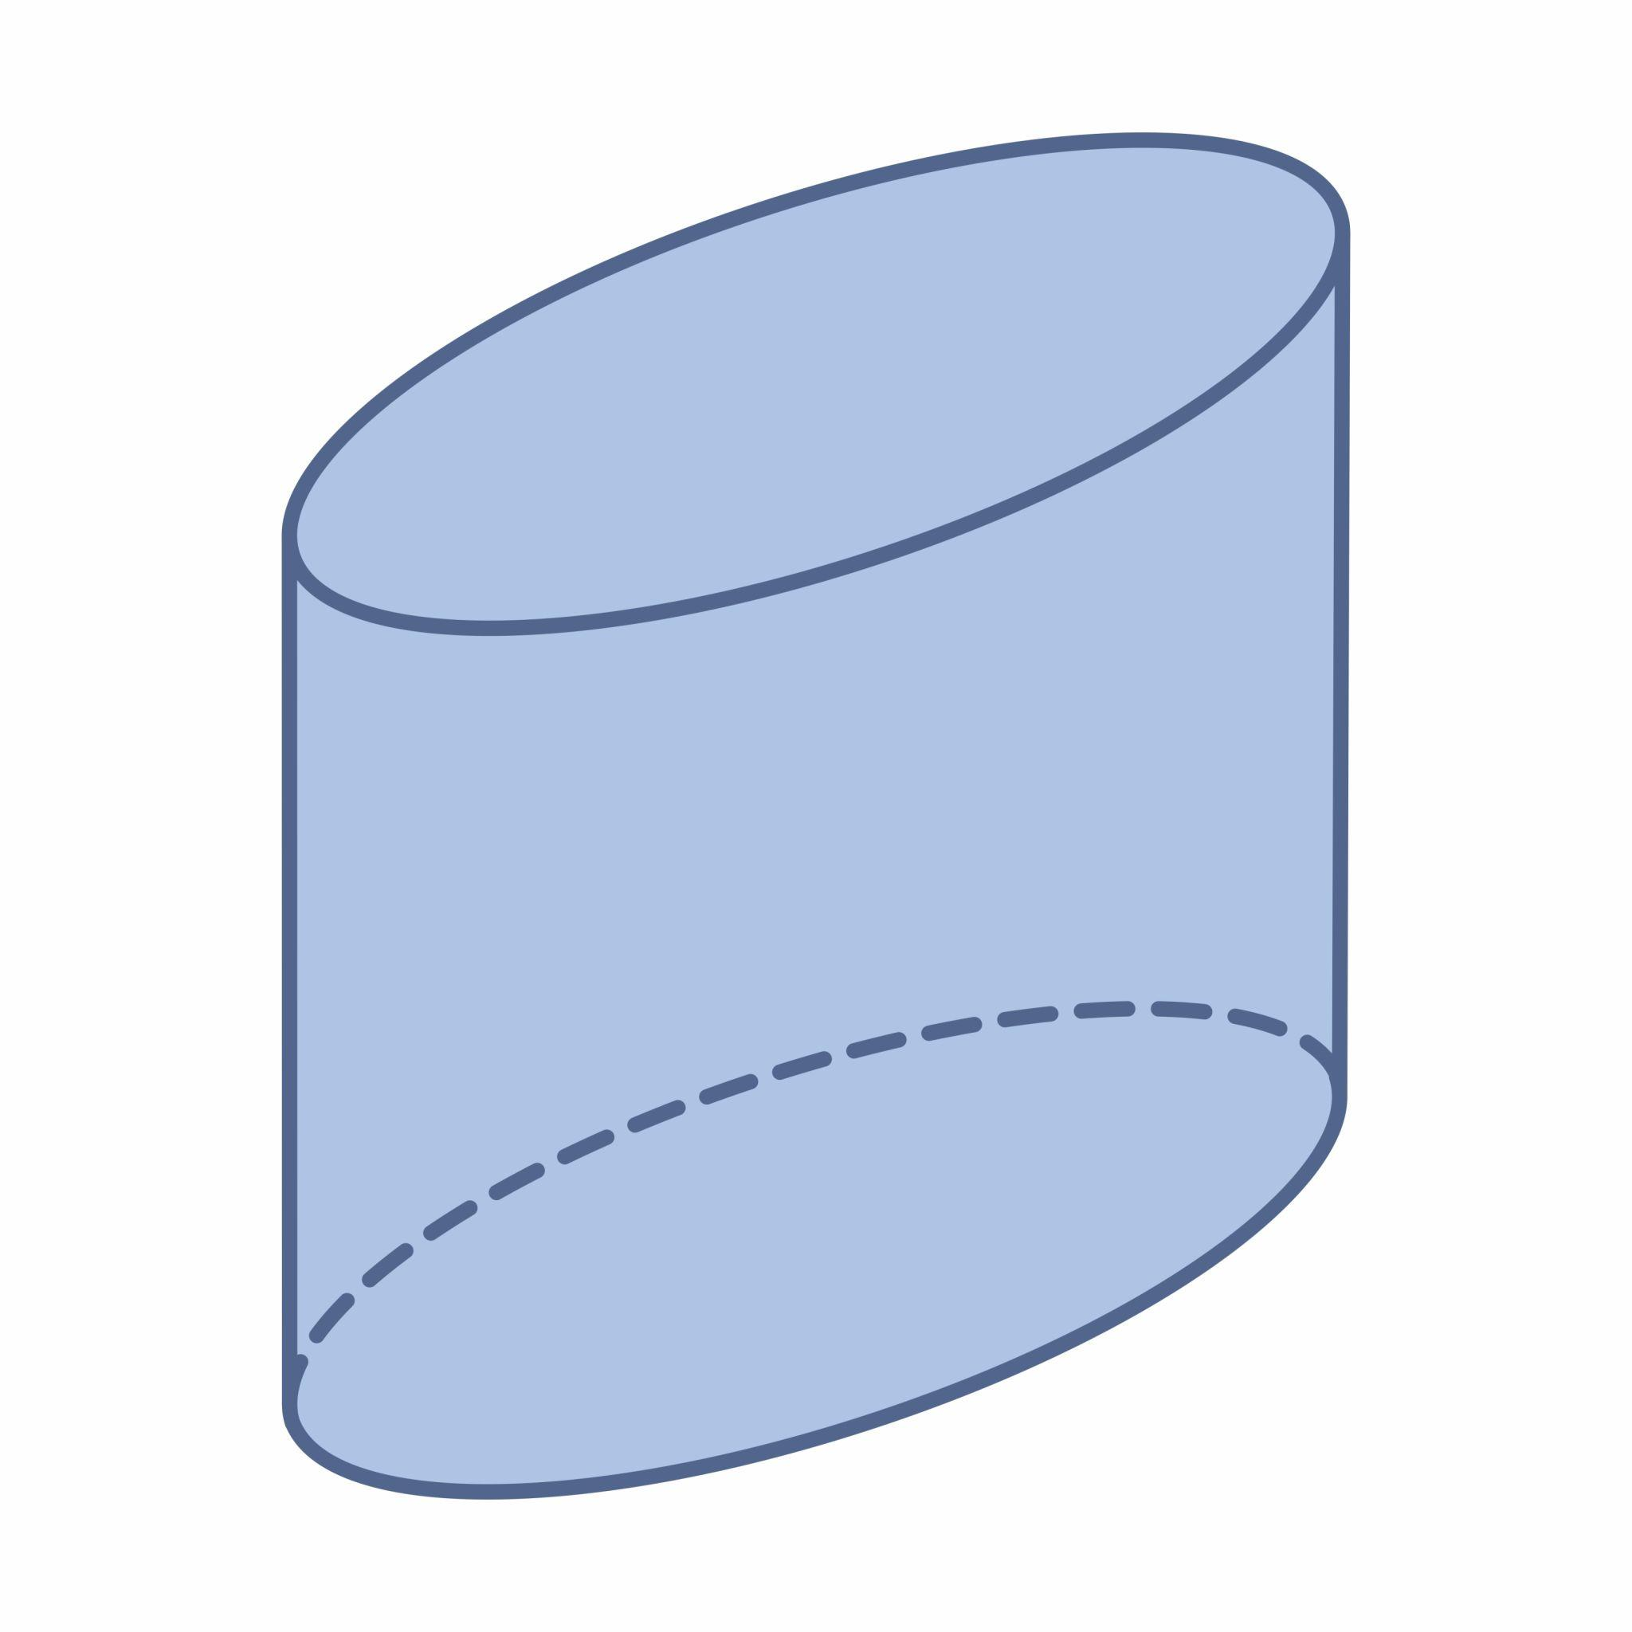
Generated by translating an elliptical region in an oblique direction relative to its plane.

Applications
# Source: AI Source: Provided by: [Data Path: Persons Table -> ID Column: 1, Name_En Column: Motasem Essam] -> From: [ChatGPT] on [7/25/2026]
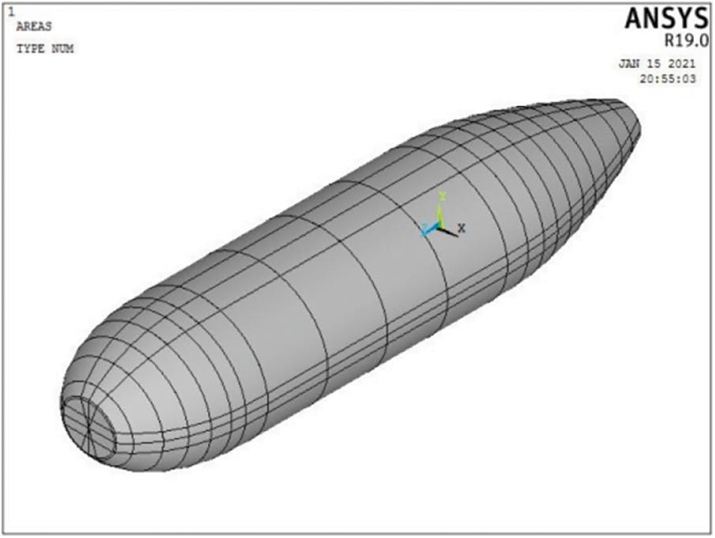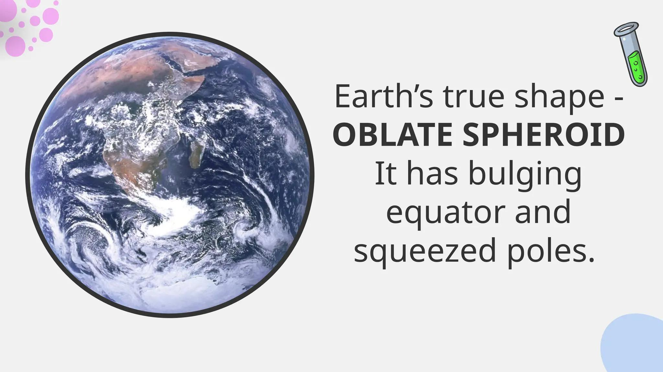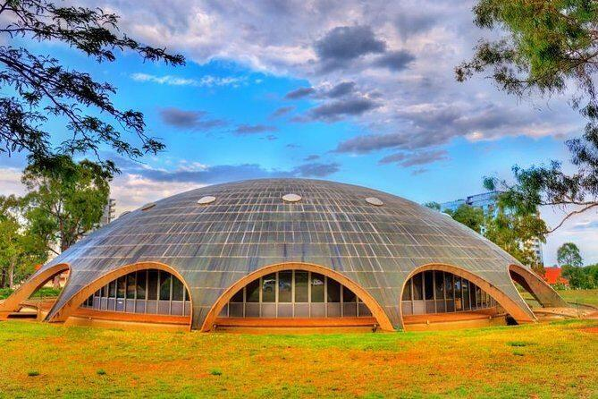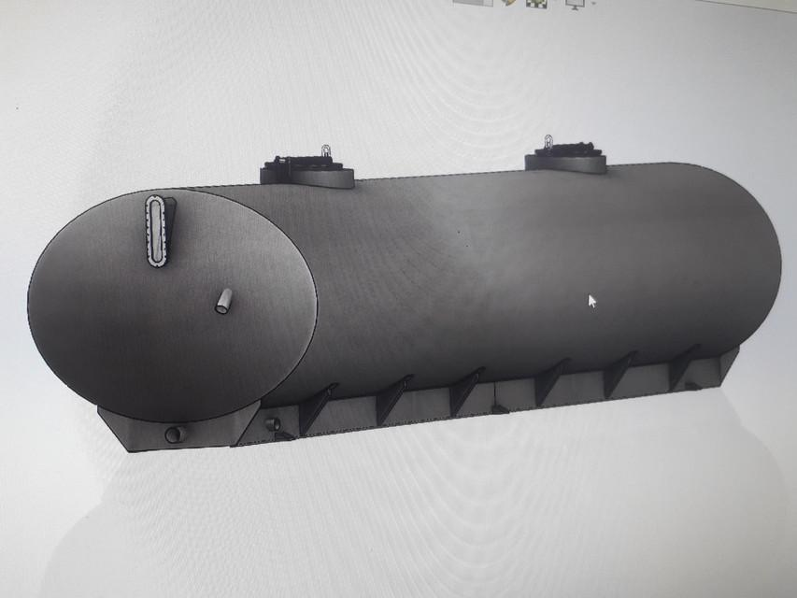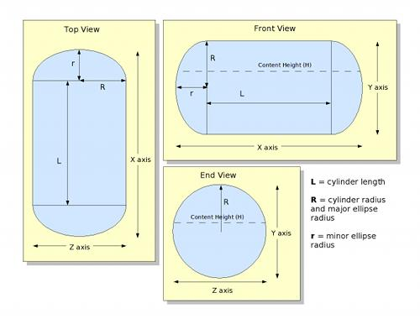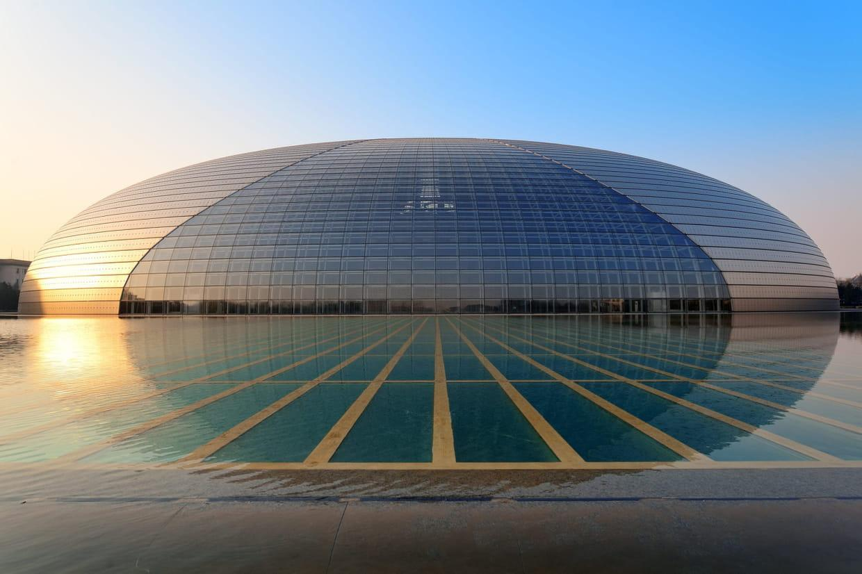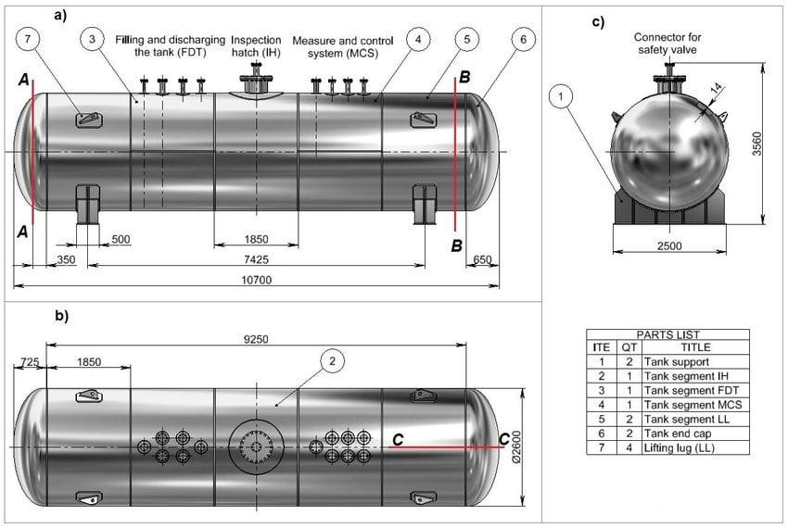
- Aerospace Engineering: Elongated spheroidal shapes in aerodynamic and structural designs.
- Planetary Models: Oblate spheroids approximate the shapes of rotating planets.
- Industrial Containers: Elliptical cylindrical tanks and vessels.
- Architecture: Elliptical domes and structural forms.
- Mechanical Engineering: Components with elliptical cross-sections.

Comparison with Other Plane-Region Generators
# Source: AI Source: Provided by: [Data Path: Persons Table -> ID Column: 1, Name_En Column: Motasem Essam] -> From: [ChatGPT] on [7/25/2026]
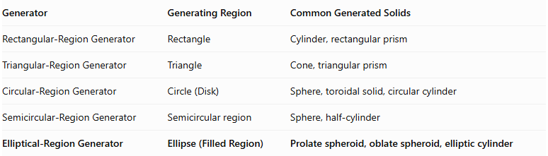
Generator | Generating Region | Common Generated Solids
Rectangular-Region Generator | Rectangle | Cylinder, rectangular prism
Triangular-Region Generator | Triangle | Cone, triangular prism
Circular-Region Generator | Circle (Disk) | Sphere, toroidal solid, circular cylinder
Semicircular-Region Generator | Semicircular region | Sphere, half-cylinder
Elliptical-Region Generator | Ellipse (Filled Region) | Prolate spheroid, oblate spheroid, elliptic cylinder

Main Classification
# Source: AI Source: Provided by: [Data Path: Persons Table -> ID Column: 1, Name_En Column: Motasem Essam] -> From: [ChatGPT] on [7/25/2026]
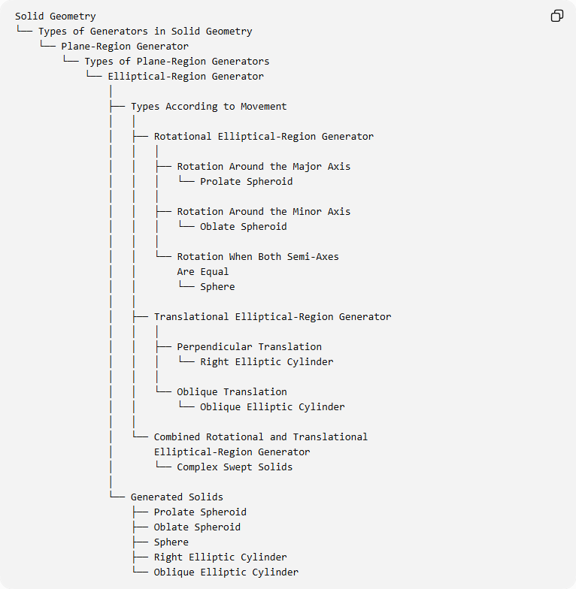
Solid Geometry
└── Types of Generators in Solid Geometry
└── Plane-Region Generator
└── Types of Plane-Region Generators
└── Elliptical-Region Generator
│
├── Types According to Movement
│ │
│ ├── Rotational Elliptical-Region Generator
│ │ │
│ │ ├── Rotation Around the Major Axis
│ │ │ └── Prolate Spheroid
│ │ │
│ │ ├── Rotation Around the Minor Axis
│ │ │ └── Oblate Spheroid
│ │ │
│ │ └── Rotation When Both Semi-Axes
│ │ Are Equal
│ │ └── Sphere
│ │
│ ├── Translational Elliptical-Region Generator
│ │ │
│ │ ├── Perpendicular Translation
│ │ │ └── Right Elliptic Cylinder
│ │ │
│ │ └── Oblique Translation
│ │ └── Oblique Elliptic Cylinder
│ │
│ └── Combined Rotational and Translational
│ Elliptical-Region Generator
│ └── Complex Swept Solids
│
└── Generated Solids
├── Prolate Spheroid
├── Oblate Spheroid
├── Sphere
├── Right Elliptic Cylinder
└── Oblique Elliptic Cylinder

Key Points
# Source: AI Source: Provided by: [Data Path: Persons Table -> ID Column: 1, Name_En Column: Motasem Essam] -> From: [ChatGPT] on [7/25/2026]
- An elliptical-region generator uses a filled ellipse as its generating figure.
- Rotating an elliptical region around its major axis generates a prolate spheroid.
- Rotating it around its minor axis generates an oblate spheroid.
- Equal semi-major and semi-minor axes produce a circular region, which generates a sphere through rotation.
- Perpendicular translation generates a right elliptic cylinder.
- Oblique translation generates an oblique elliptic cylinder.
- A general ellipsoid with three unequal principal axes cannot be generated by simply rotating one ellipse around a principal axis.

Conclusion
# Source: AI Source: Provided by: [Data Path: Persons Table -> ID Column: 1, Name_En Column: Motasem Essam] -> From: [ChatGPT] on [7/25/2026]
The Elliptical-Region Generator is an important plane-region generator in solid geometry. Its principal applications are generating prolate and oblate spheroids through rotation and elliptic cylinders through translation.

